Charles City Water Resources Recovery Facility

City of Charles City
Site: 307 Shaw Ave.
Charles City, IA 50616
641-257-6318

3/12/2019
Designed By:
FOX Engineering Associates Inc.
414 South 17th Street
Suite 107
Ames, IA 50010

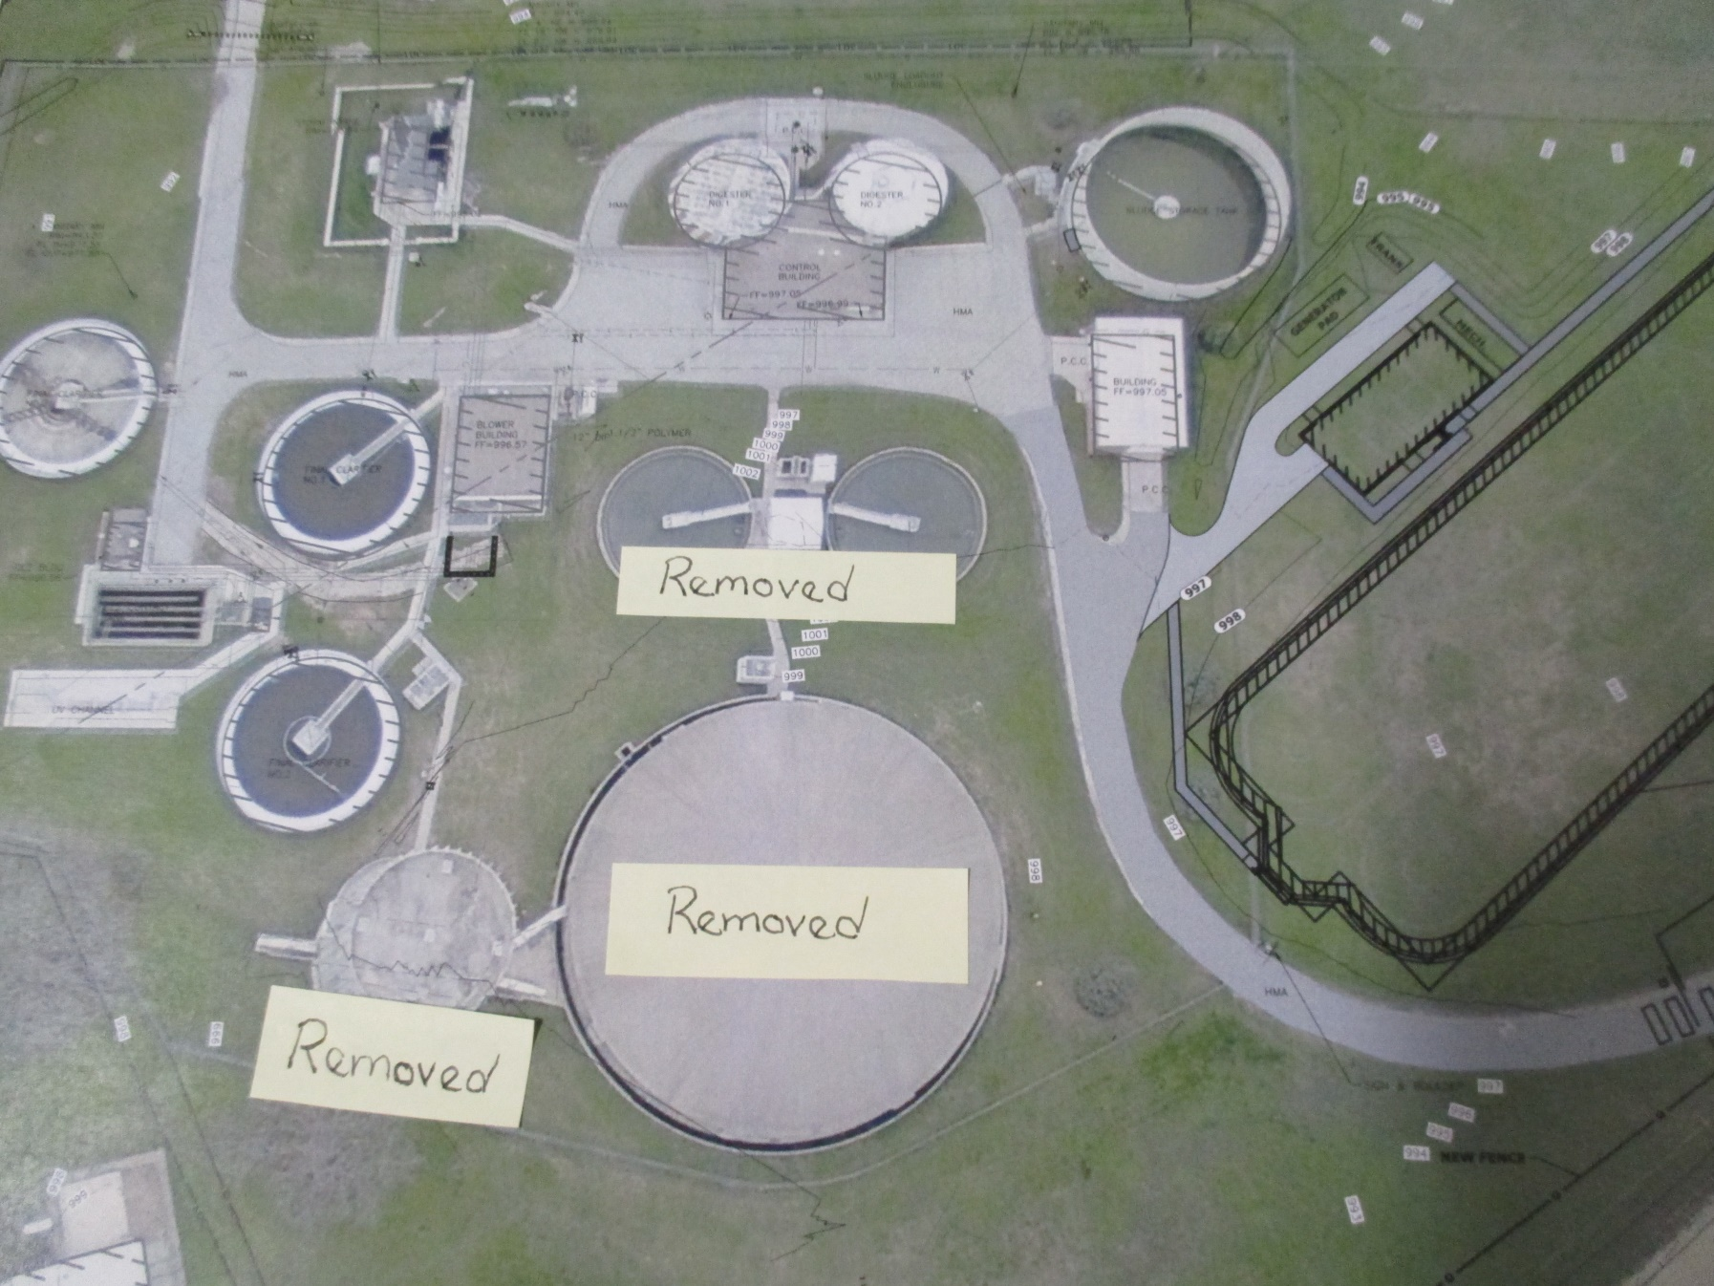
NEW PLANT LAYOUT
- Oxidation Ditches-right side
- New Headworks Building adjacent to Oxidation Ditches which will house automatic bar-screen, grit system, controls, and sampling
- Automatic Backup Generator
- New Pumps and Controls including Equalization Pumps
- Re-designed Recycling and Wasting Process
- Existing Sludge Storage Tank will become Digester #3
Removals
Trickling Filter-the big dome, Bio-Tower the tall structure, the 2 Primary clarifiers

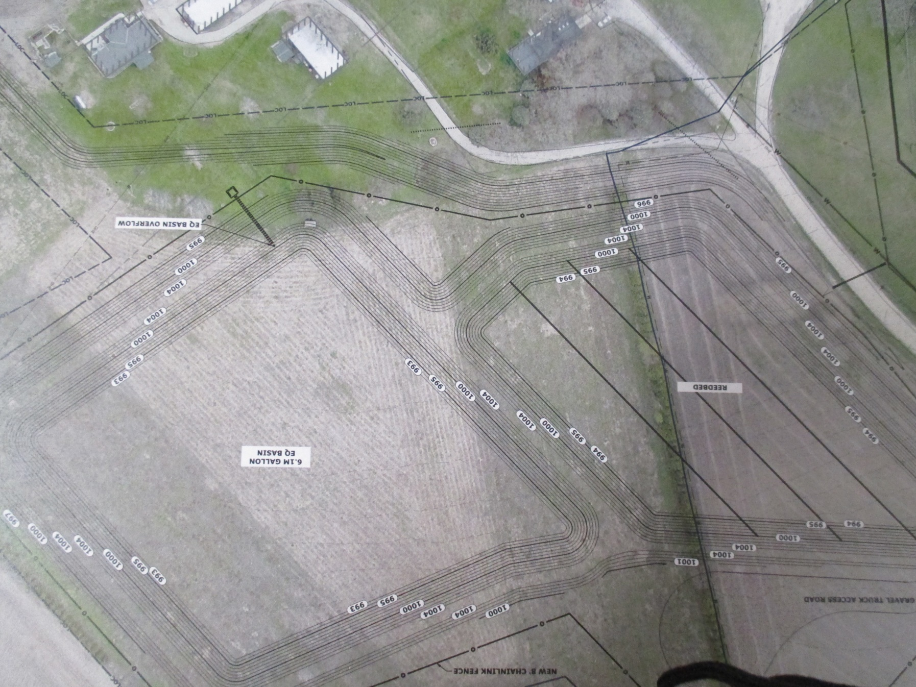
EQUALIZATION BASIN AND REED BEDS
Plants needs to be sized to meet max wet weather flows, so with having an equalization basin we can size the new portion of plant for average wet weather flows because we can store max wet weather flows and bring stored material back to head of plant to treat after weather events subside.
Activated sludge plants generate more solids at lower percent solids content. We would have to have more fields available season long, personal to haul, and new hauling machinery. To put this in perspective we would be going from 550,000 gallons average to around 3,000,000 gallons of solids to haul if we stay with land applying as we do it now. Reed Beds will allow this earthy in nature material to be stored and water to release back to the head of the plant. We will end up with dry fertilizer that will have beneficial end use.

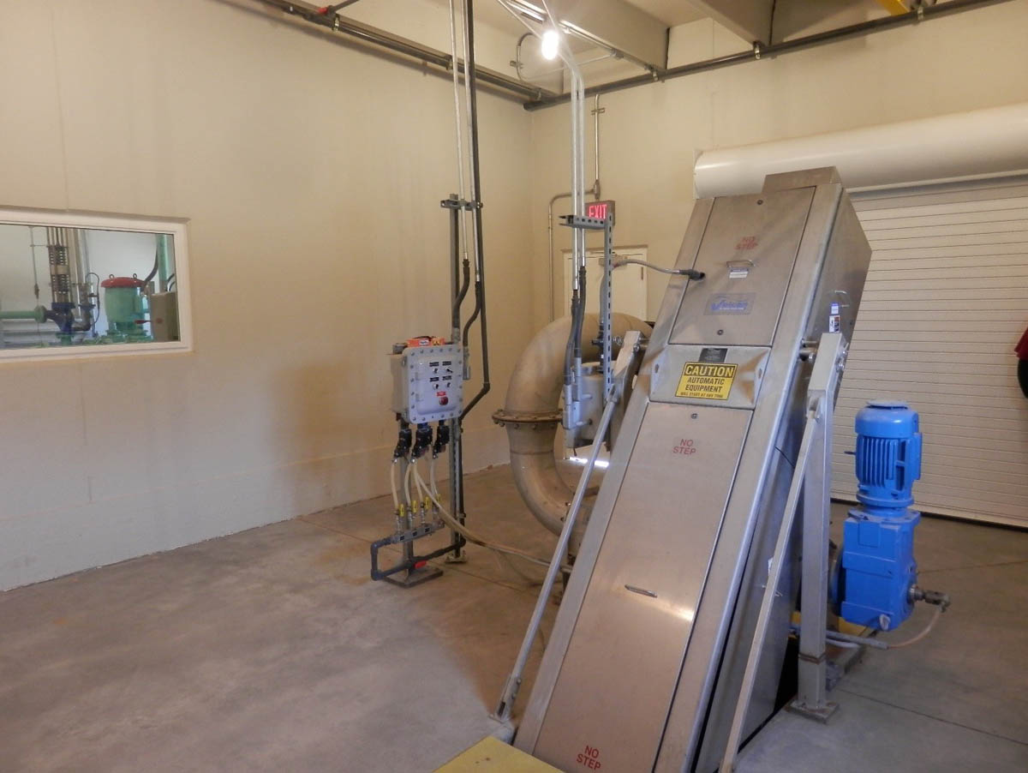
Bar Screen Video
Here is an example of a step bar-screen. It will sense a buildup of material and will cycle upwards to the point the material will fall into a screen wash press where the water content is removed and screenings will fall into a dumpster. We will be able to capture more material at this point which will keep rags from interfering with treatment process.

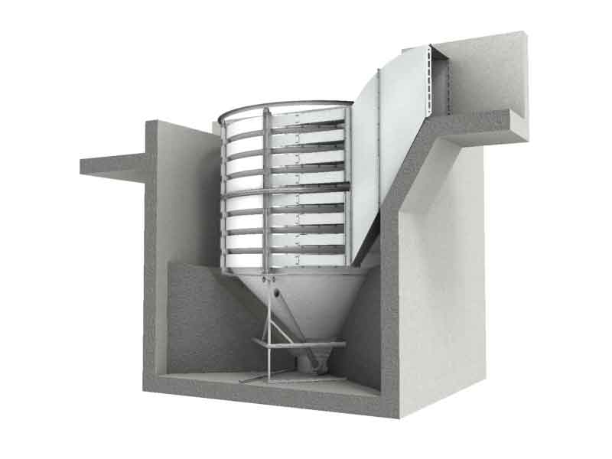
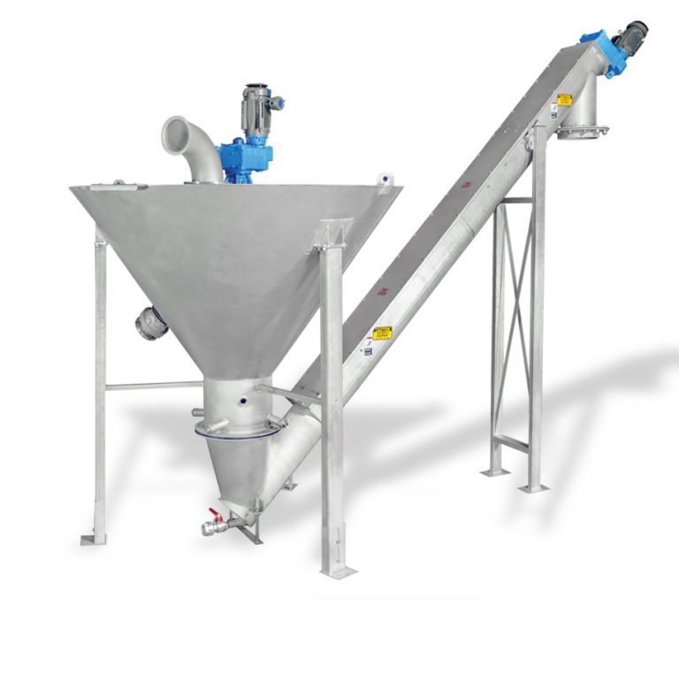
Above left is the type of grit system that will follow after water passes through the step screen. Sand, gravel, and non-organic material fall into center where they are removed from the waste stream before the flow enters the oxidation ditch. Removed material will go through a cleaning process called a grit washer (above right side) before it is conveyed into a dumpster. Organic material will then be released back into the influent stream.

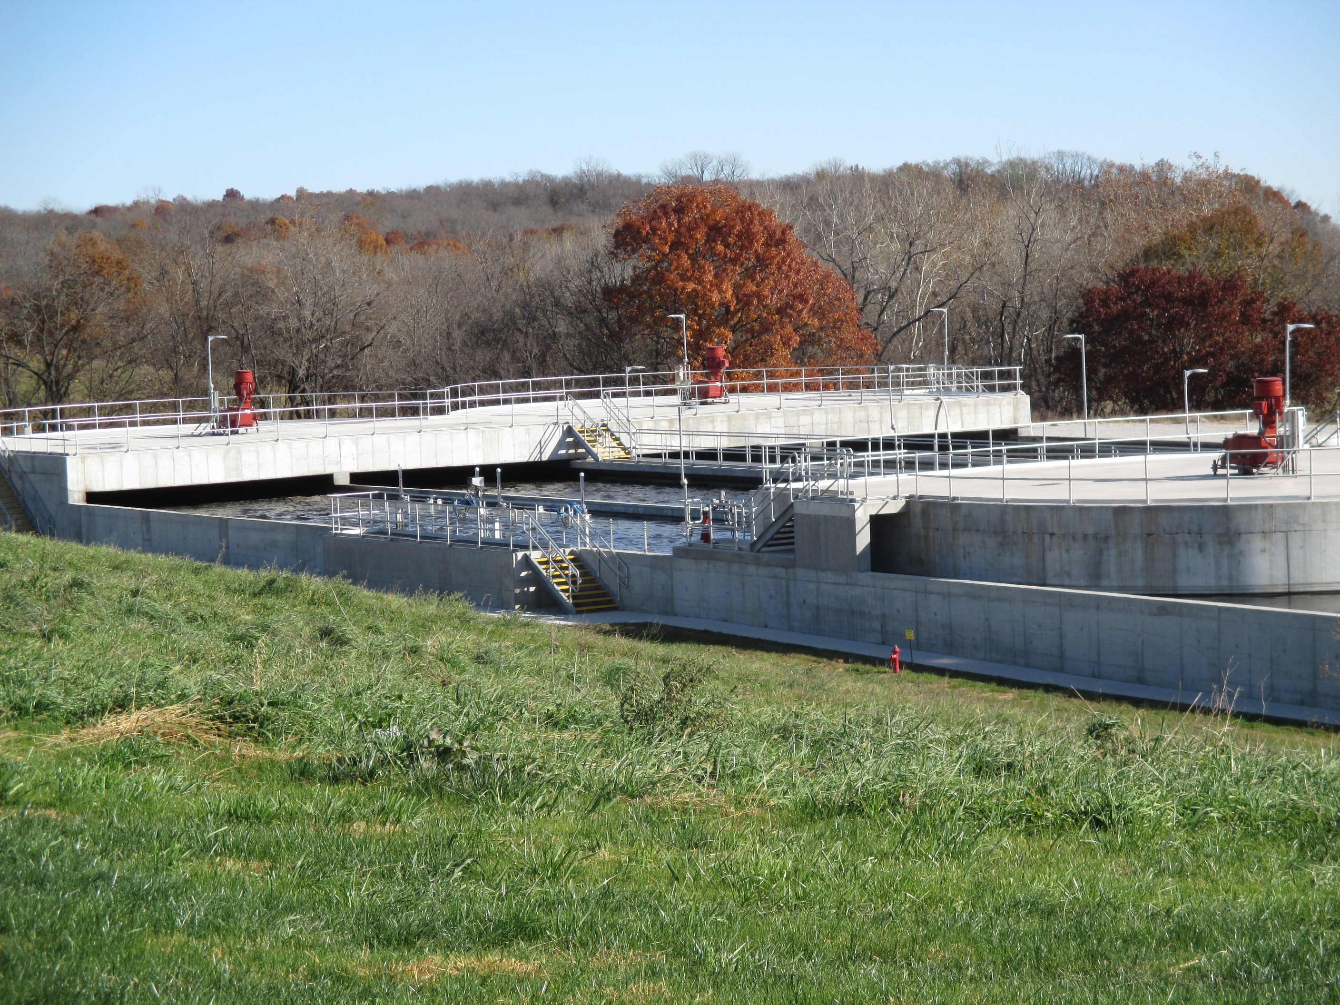
Above is an example of an Oxidation Ditch. An oxidation ditch is a modified activated sludge biological treatment process that has long solids retention time (SRT) to remove biodegradable organics. The structure has dedicated treatment zones to treat organics, solids, and for total nitrogen and phosphorus to meet new nutrient effluent quality goals. Zones are dedicated by the amount of dissolved oxygen in the water; Anaerobic Zone (no D.O.), Anoxic (little to no D.O), and Aerobic Zone (D.O. required). Mixed liquor will continually flow out and be recycled back and mixed with influent flow to keep organisms in the system for a SRT of around 15 days until they are finally removed into the biosolids treatment process.

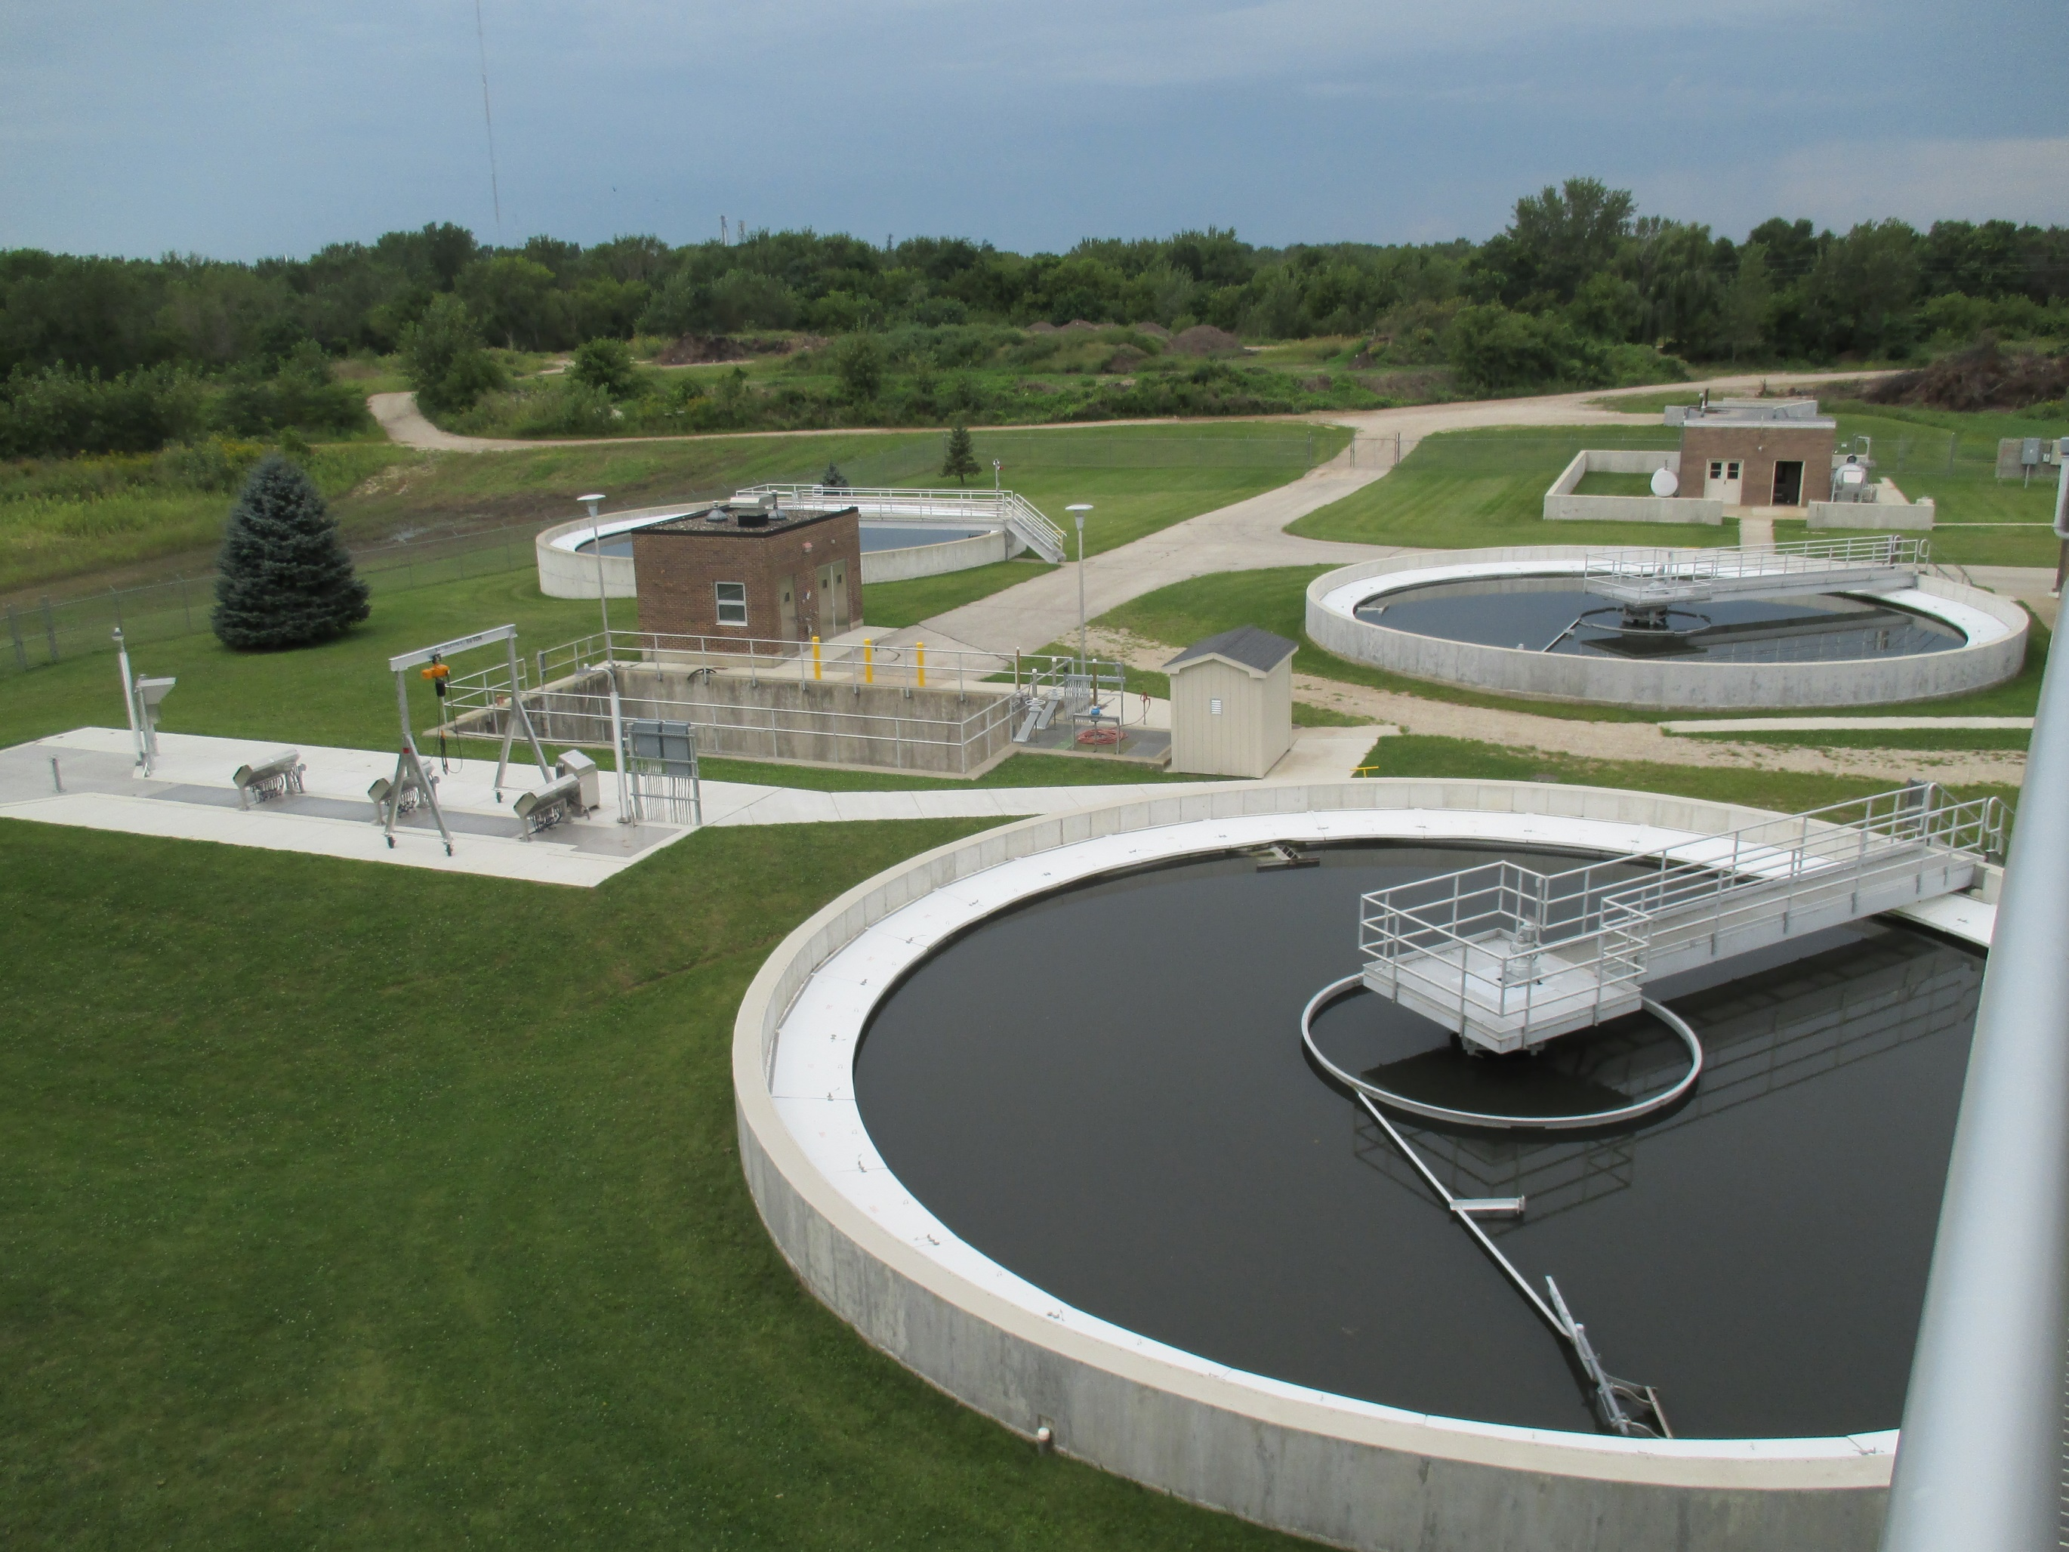
These are our existing final clarifies which will continue to be used along with the Ultraviolet Disinfection System (left center). Treated water flows out of the oxidation ditches into these final clarifiers where solids are removed and will either be recycled back to the oxidation ditches or wasted to our digester system. Clean water that flows over the top weirs will then pass through the disinfection system before it leaves the plant.

Projected Milestone | Year
Submit Facility Plan | July 2017
Facility Plan Approval | September 2017
Preliminary Plans and Specifications Submittal | October 2017
Final Plans and Specifications Submittal | April 2019
Bid Project | Aug 2019
Award Project | Aug 2019
Begin Construction of New WRRF | Sept 2019
New Treatment Process Operational | Dec 2021
Complete Construction of New WRRF / Final Closeout | May 2022

